http://www.npr.org/blogs/health/2013/06/24/193483931/Contagious-Thinking-Can-Be-Depressing

Gloomy Thinking Can Be Contagious
by SHANKAR VEDANTAM
June 24, 2013 2:59 AM

Listen to the Story
Morning Edition
4 min 25 sec
- Playlist
- Download
- Transcript
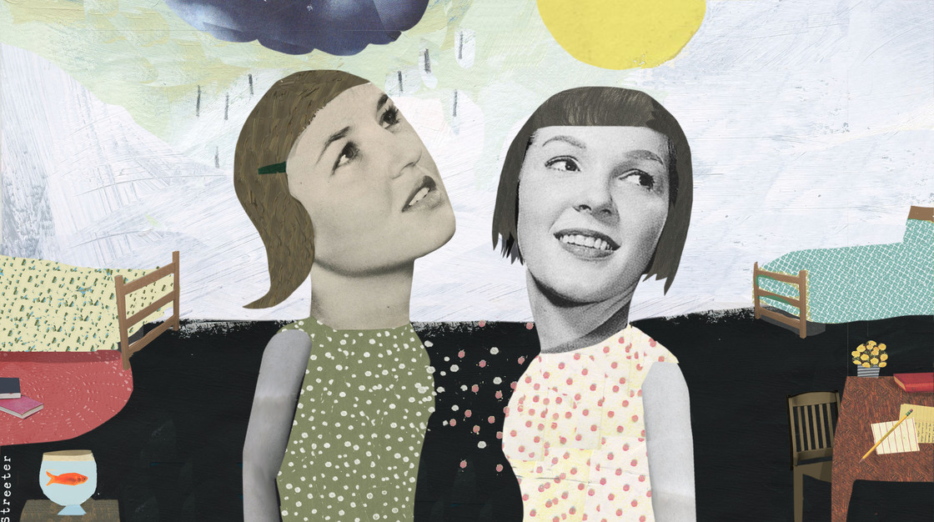
Katherine Streeter for NPR
When students show up at college in the fall, they'll have to deal with new classes, new friends and a new environment. In many cases, they will also have new roommates — and an intriguing new research study suggests this can have important mental health consequences.
At the University of Notre Dame, psychologist Gerald Haeffel has recently obtained results from a natural experiment that unfolds every year at the university. In a paper published recently in the journal Clinical Psychological Science, Haeffel and co-author Jennifer Hames report that roommates can have strong effects — both positive and negative — on one another's mental health.
Like many schools, Notre Dame assigns new students their roommates. Haeffel recruited some of the students for a study and measured their psychological predispositions.
One of the things he was interested in was how different students respond to adversity. Take, for example, two hypothetical young scholars who do poorly on a classroom test: "One student fails the exam and thinks to [herself], 'I'm dumb, I'm worthless. I can't believe I failed this exam,'" Haeffel says. The same student may also engage in catastrophic thinking, imagining that because she failed the exam, she's going to fail the class or even flunk out of college.
By contrast, though the other student also tells herself it was disappointing to fail, she puts it down to a lack of preparation. She tells herself, "I'll work harder next time."
"These two reactions to the very same event can have very real implications for depression," Haeffel says. The student who sees the failure in extremely personal terms and then extrapolates from that failure to a host of other problems down the road is at significantly higher risk of depression, he says, than the student who puts the setback down to circumstances and bounces back from it. RESILIENCE
Haeffel and Hames measured the way students in their study tended to frame such situations when they first arrived at Notre Dame. The researchers were then able to track pairs of roommates who had similar thinking styles and see whether and how their thought patterns changed, in comparison to roommate pairs who started out with very different thinking styles.
Haeffel says he was surprised to find that within just three months, the roommates with different styles began to "infect" one another.
"These thinking styles were contagious," he says. "If you came to college and your roommate had a very negative thinking style, your own thinking style became more negative."
Haeffel says that it "seems counterintuitive that you can catch someone's style of thinking like you could catch a cold or the flu." But six months after living with a roommate with a negative thinking style, some formerly cheerful students were showing signs of cognitive vulnerability known to put them at risk for depression.
Interestingly, Haeffel found that the reverse could be true as well. Some students with a gloomy disposition who got a cheerful, upbeat roommate were more likely to be cheerful and upbeat six months later. When confronted by a setback, such as a bad grade or a romantic breakup, these students began demonstrating some of the resilience of their cheerful companions.
Haeffel says the study showed that a widely held model about temperament and behavior might need revision. Researchers have long assumed, he says, that the positive and negative traits he spotted in the college students were more or less fixed after adolescence, in part because those traits seem stable in people over subsequent decades.
But instead, he says, those traits may be more like a language than like a physical characteristic such as height. By adolescence, people get very good at speaking a certain psychological language — responding to adversity in a certain, fixed way. But just as people can learn a new tongue if they're suddenly immersed in a new environment where people around them are speaking a different language, the experience of coming to college might have the same effect on the psychological makeup of young adults, Haeffel says. When gloomy people spend lots of time with someone who has a cheerful outlook, it can change their psychological "language." When cheerful people spend time around gloomy roommates, it can darken their outlook.
The point of the findings, Haeffel says, is not that you have to surround yourself with cheery people all the time — at a practical level, that's impossible. Rather, he says, it's good to know that some internal traits are malleable and, with time and effort, people can teach themselves new "languages."
++++++++++++++++++++++++++++++++++++++++++++++

http://www.npr.org/blogs/health/2013/06/24/193884835/depression-may-increase-the-risk-of-dementia-later-on

Depression May Increase The Risk Of Dementia Later On
by PATTI NEIGHMOND
June 24, 2013 2:58 AM

Listen to the Story
Morning Edition
3 min 47 sec
- Playlist
- Download
- Transcript
Depression is common among old people, affecting up to 25 percent.
iStockphoto.com
Depression can have physical consequences. Research now suggests that when people get depressed in middle age and beyond, they're more likely to develop dementia in old age.
But the link between depression and dementia remains something of a mystery. Researchers are working to understand why that occurs and what might be done to prevent dementia.
Brain researcher Meryl Butters with the University of Pittsburgh School Of Medicine has spent years trying to answer this question. She asks, "What is it about a mood disorder that is relatively treatable, that people can recover from; what is it in the brain that may increase one's risk for dementia many years later?"
Dementia can be caused by different diseases, including Alzheimer's disease and vascular dementia, which follows a stroke or series of mini strokes. In a recent study, Butters found that the risk for both of those types of dementia nearly doubled among people who had suffered depression after the age of 50.
There are some clues as to why that may be. Depression is associated with inflammation in the body, and inflammation also appears to play a role in cardiovascular disease. Scientists are trying to figure out if the inflammation in the two disorders is linked.
The thickening of blood vessel walls in atherosclerosis makes it "difficult for blood to get through to nourish the brain and give the brain all the oxygen that it needs," Butters says, and a less nourished brain might mean greater vulnerability to dementia. Even if this theory doesn't hold up, she says, there's no harm in doing for your brain what you do for your heart: maintain a normal weight, eat a healthy diet and exercise regularly.

Shots - Health News

How Exercise And Other Activities Beat Back Dementia
Butters suggests another clue that may link depression to dementia. It involves the stress hormone cortisol. When people get depressed, they produce excess amounts of cortisol. Butters says that could be problematic for a part of the brain called the hippocampus.

Shots - Health News

Sleepless Nights May Put The Aging Brain At Risk Of Dementia
"It just so happens that the hippocampus has lots of cortisol receptors," Butters says. "So it may be that if you have high levels of cortisol circulating for long periods of time, they can sort of burn out, for lack of a better term, and die and then the hippocampus shrinks."
The hippocampus is responsible for learning and short-term memory. In early-stage dementia, the hippocampus is one of the first regions of the brain to show symptoms. People often forget things that just happened, like what they ate for breakfast or what they just said to someone.
One study found that women who had a long history of depression had a smaller hippocampus compared to women of the same age who didn't. But researchers have yet to prove that the brain changes seen in depression contribute to dementia later on.
Dr. Charles Reynolds, a geriatric psychiatrist at the University of Pittsburgh Medical Center, says preventing depression could be an important defense against dementia. "I think the good news is that we can help older people and their family caregivers take steps to protect themselves from becoming clinically depressed", he says. If successful, that might ultimately help delay or prevent dementia.
Reynolds recently looked at ways to help older adults prevent depression. In his study, counselors visited people in their homes, looking for problems that could lead to depression including difficulty sleeping, lack of exercise, poor nutrition and social isolation.
Each participant met with a counselor for six to eight sessions; the counselor helped people tackle these problems themselves. As a result, the grim predictions that one in four older adults would suffer major depression just didn't pan out for this group. "Over a period of two years, incidence was reduced to about 8 or 9 percent," says Dr. Reynolds. That's down by two-thirds. This was true for both black and white older adults, as well as those with low and moderate incomes.
So now the next step is for researchers to determine whether lowering rates of depression among middle aged and older people can also protect them against dementia.

